Hp@LAPTOP-0QAJ5O1J MINGW64 ~

$ mkdir project_dir

Hp@LAPTOP-0QAJ5O1J MINGW64 ~

$ cd project_dir

Hp@LAPTOP-0QAJ5O1J MINGW64 ~/project_dir

$ git init

Hp@LAPTOP-0QAJ5O1J MINGW64 ~/project_dir

$ git init

Initialized empty Git repository in C:/Users/Hp/project_dir/.git/

Hp@LAPTOP-0QAJ5O1J MINGW64 ~/project_dir (master)

$ touch index.html

Hp@LAPTOP-0QAJ5O1J MINGW64 ~/project_dir (master)

$ git status

On branch master

No commits yet

Untracked files:

(use "git add <file>..." to include in what will be committed)

index.html

nothing added to commit but untracked files present (use "git add" to track)

Hp@LAPTOP-0QAJ5O1J MINGW64 ~/project_dir (master)

$ git add index.html

Hp@LAPTOP-0QAJ5O1J MINGW64 ~/project_dir (master)

$ git status

On branch master

No commits yet

Changes to be committed:

(use "git rm --cached <file>..." to unstage)

new file: index.html

Hp@LAPTOP-0QAJ5O1J MINGW64 ~/project_dir (master)

$ git commit -m "committing index.html file"

[master (root-commit) 8710d5a] committing index.html file

1 file changed, 0 insertions(+), 0 deletions(-)

create mode 100644 index.html

Hp@LAPTOP-0QAJ5O1J MINGW64 ~/project_dir (master)

$ touch info.txt

Hp@LAPTOP-0QAJ5O1J MINGW64 ~/project_dir (master)

$ git status

On branch master

Untracked files:

(use "git add <file>..." to include in what will be committed)

info.txt

nothing added to commit but untracked files present (use "git add" to track)

Hp@LAPTOP-0QAJ5O1J MINGW64 ~/project_dir (master)

$ git status

On branch master

Changes not staged for commit:

(use "git add <file>..." to update what will be committed)

(use "git restore <file>..." to discard changes in working directory)

modified: index.html

Untracked files:

(use "git add <file>..." to include in what will be committed)

info.txt

no changes added to commit (use "git add" and/or "git commit -a")

Hp@LAPTOP-0QAJ5O1J MINGW64 ~/project_dir (master)

$ touch .gitignore

Hp@LAPTOP-0QAJ5O1J MINGW64 ~/project_dir (master)

$ git status

On branch master

Changes not staged for commit:

(use "git add <file>..." to update what will be committed)

(use "git restore <file>..." to discard changes in working directory)

modified: index.html

Untracked files:

(use "git add <file>..." to include in what will be committed)

.gitignore

info.txt

no changes added to commit (use "git add" and/or "git commit -a")

Hp@LAPTOP-0QAJ5O1J MINGW64 ~/project_dir (master)

$ git commit -m "First commit"

On branch master

Changes not staged for commit:

(use "git add <file>..." to update what will be committed)

(use "git restore <file>..." to discard changes in working directory)

modified: index.html

Untracked files:

(use "git add <file>..." to include in what will be committed)

.gitignore

info.txt

no changes added to commit (use "git add" and/or "git commit -a")

Hp@LAPTOP-0QAJ5O1J MINGW64 ~/project_dir (master)

$ git add index.html

Hp@LAPTOP-0QAJ5O1J MINGW64 ~/project_dir (master)

$ git commit -m "First commit"

[master b43b0d1] First commit

1 file changed, 1 insertion(+)

Hp@LAPTOP-0QAJ5O1J MINGW64 ~/project_dir (master)

$ git log

commit b43b0d122a4bf256ddadcc8ad97a3283acb9a86e (HEAD -> master)

Author: manoj1927 <manu.ckj2000@gmail.com>

Date: Sun Jun 19 13:47:25 2022 +0530

First commit

commit 8710d5abf9ad1e406b09d3c0ea7c7d147dbadc7b

Author: manoj1927 <manu.ckj2000@gmail.com>

Date: Sun Jun 19 13:12:22 2022 +0530

committing index.html file

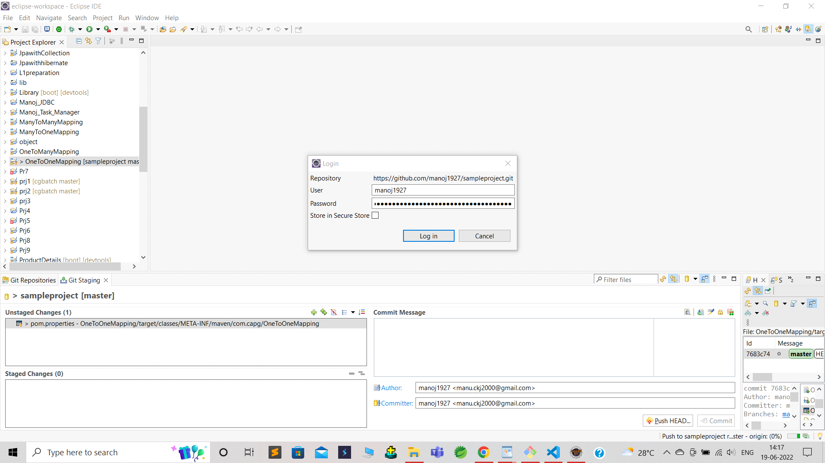

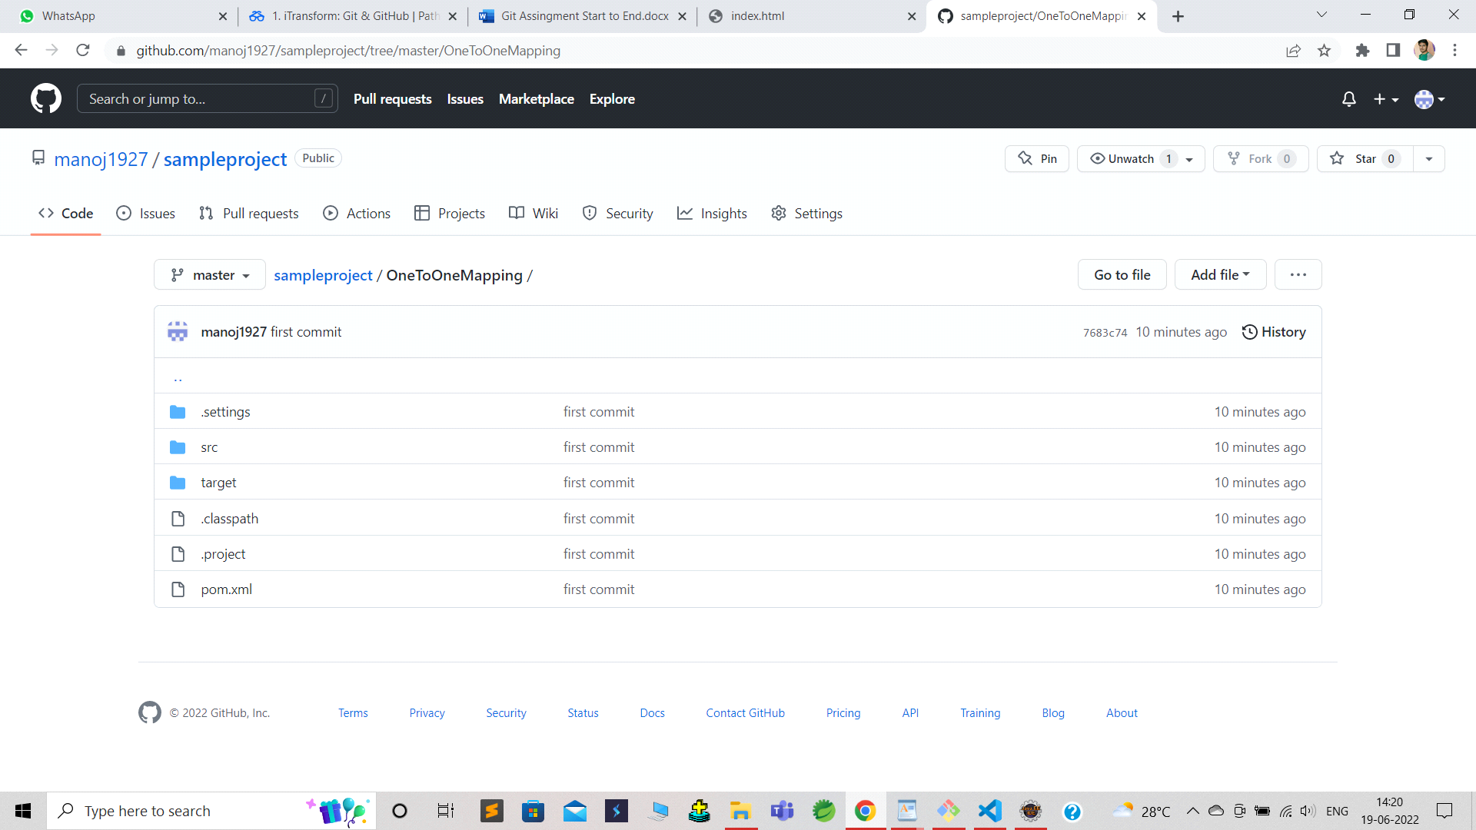

Mongo DB

1. get all documents

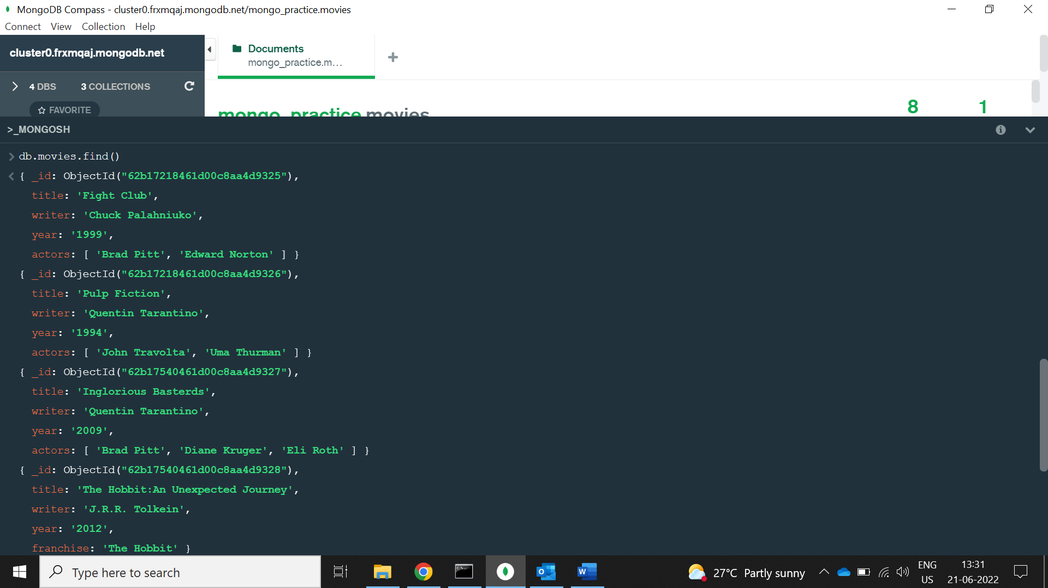

1. get all documents with writer set to "Quentin Tarantino"

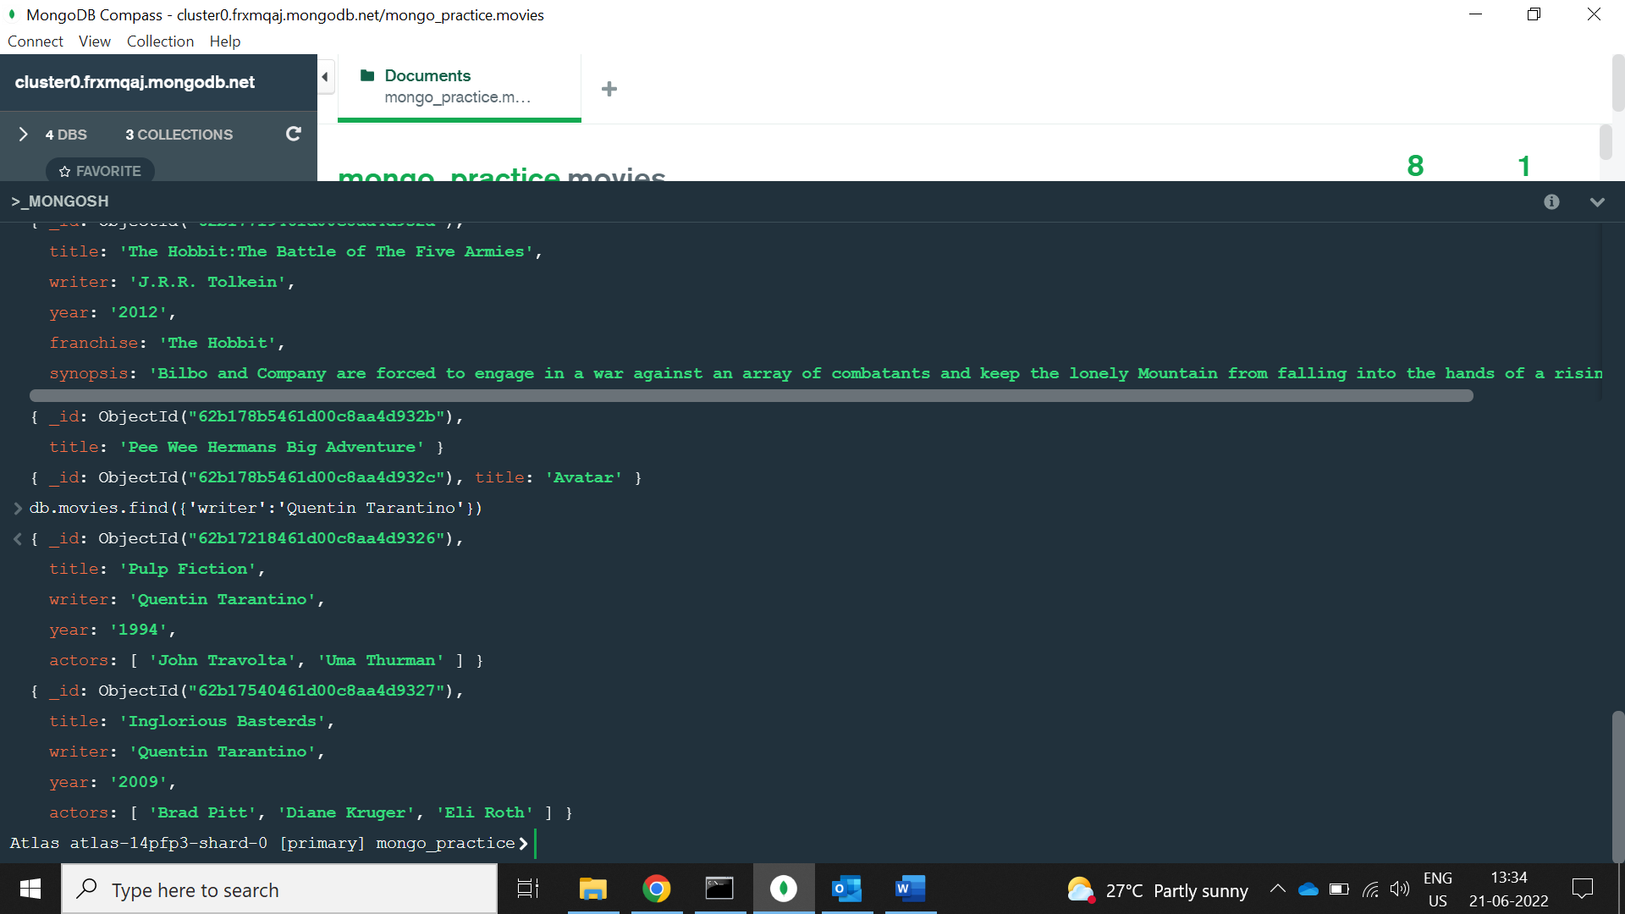

1. get all documents where actors include "Brad Pitt"

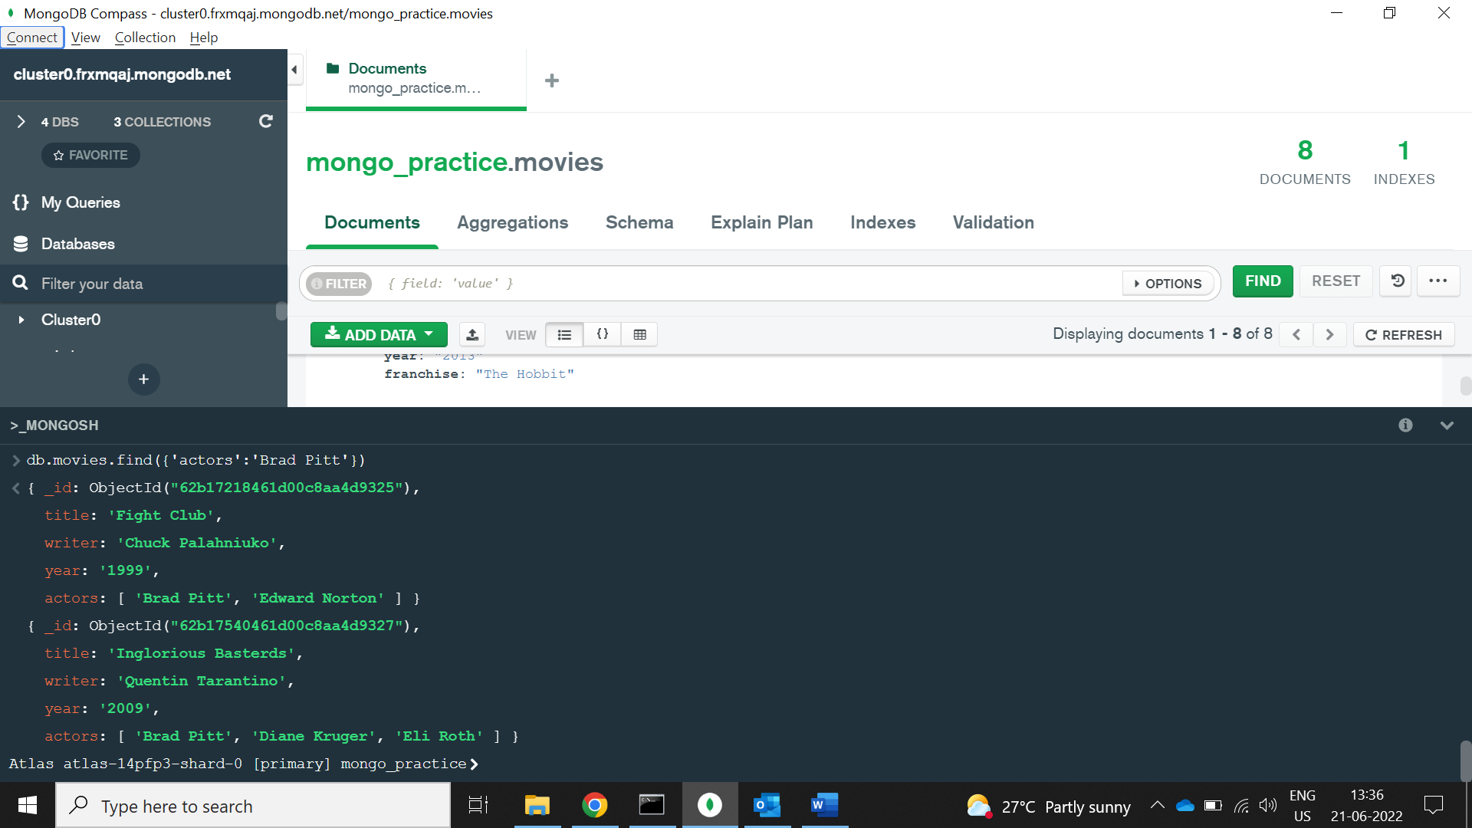

1. get all documents with franchise set to "The Hobbit"

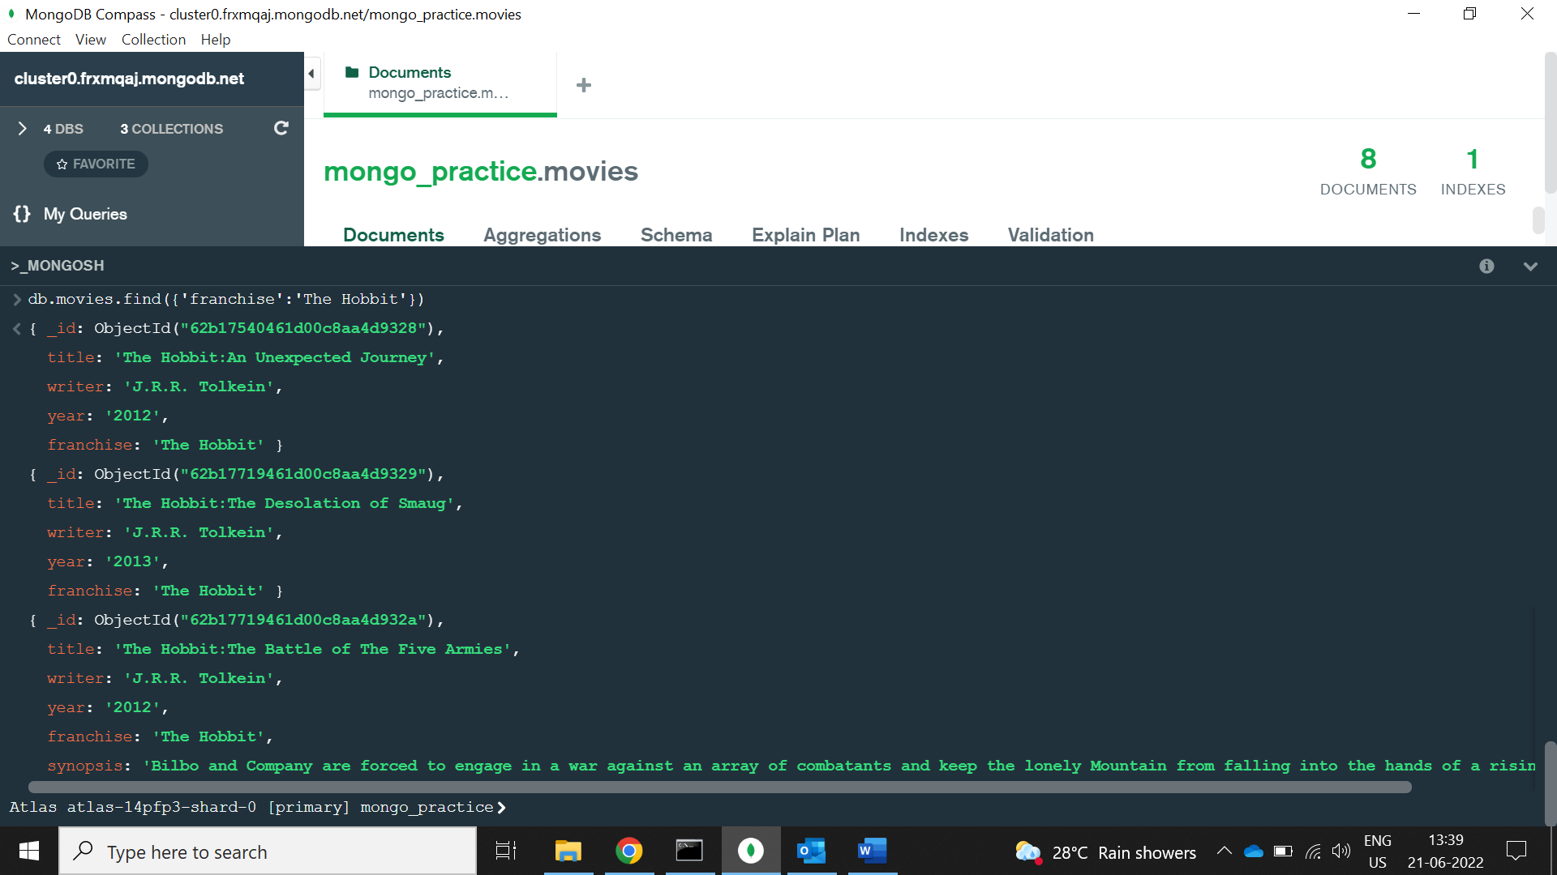

1. get all movies released in the 90s

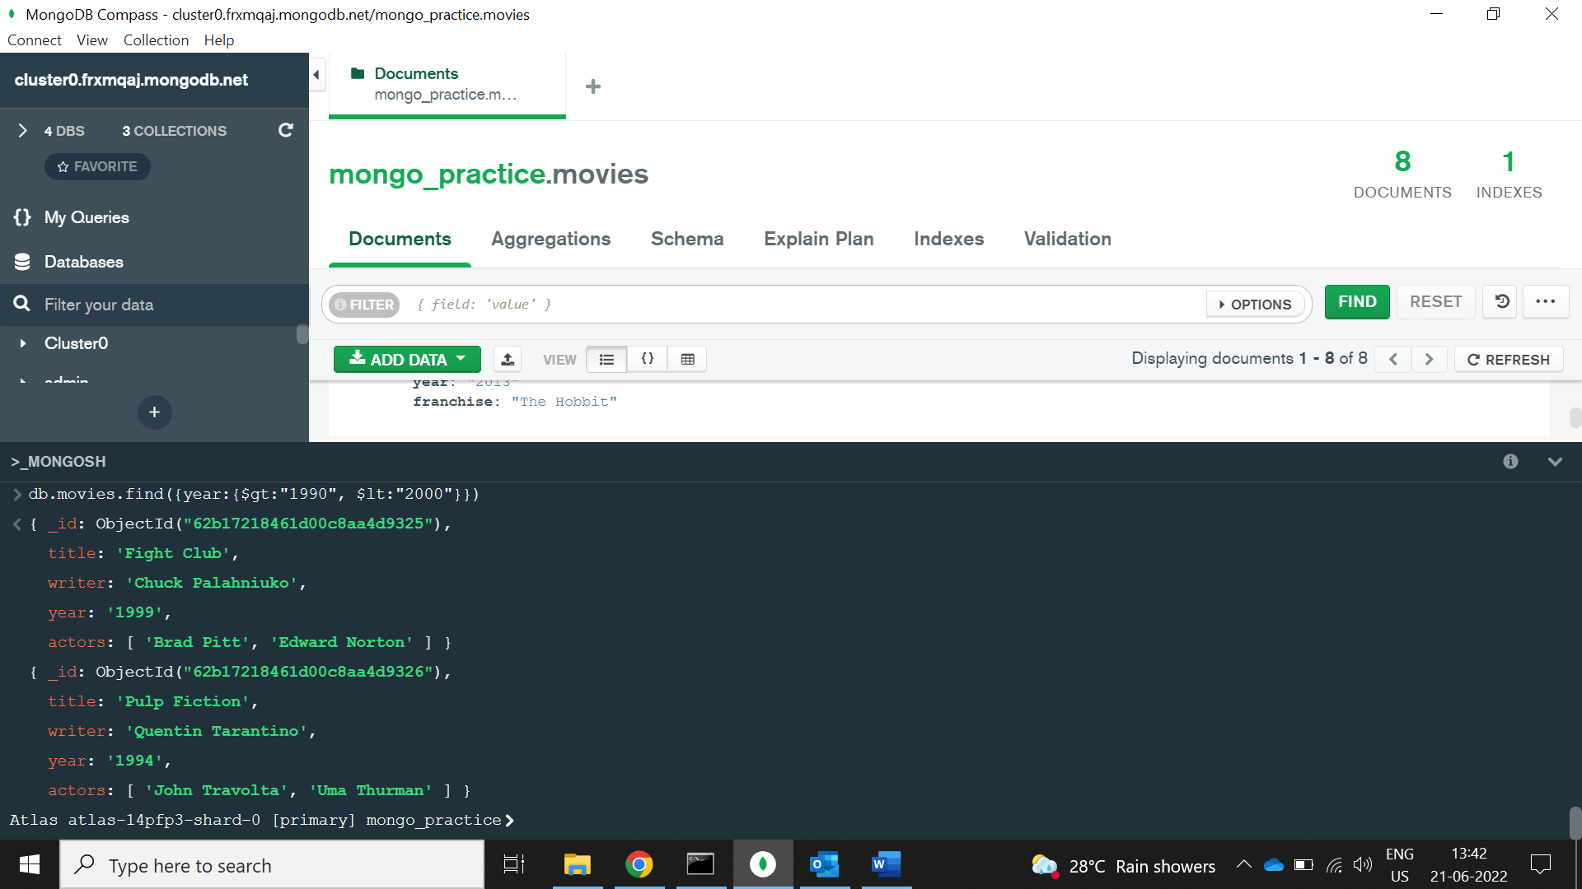

1. get all movies released before the year 2000 or after 2010

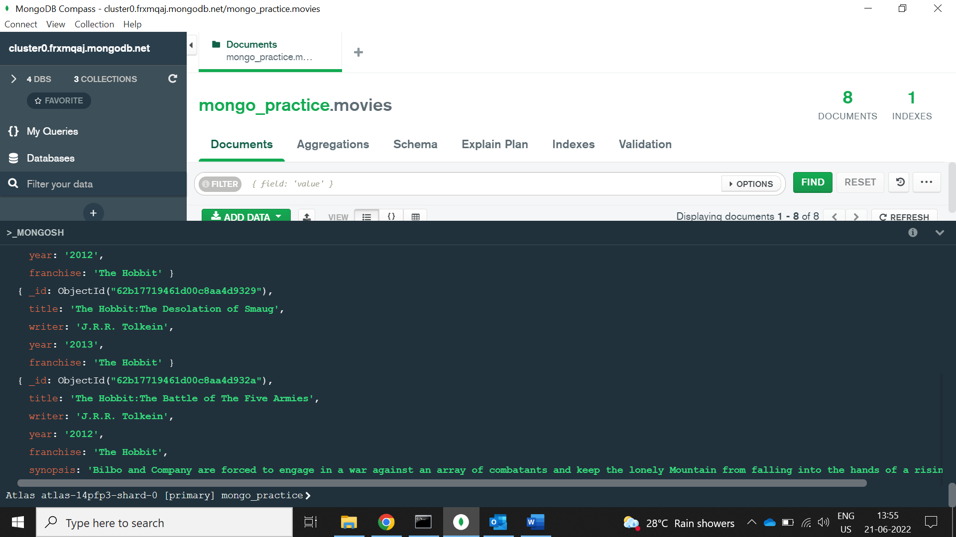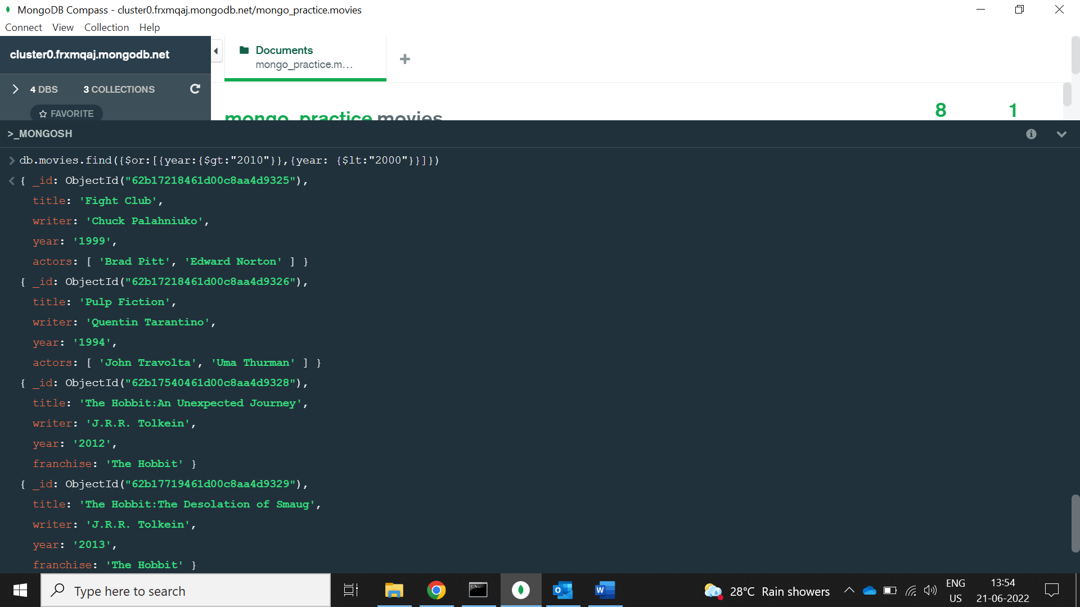

**Update Documents**

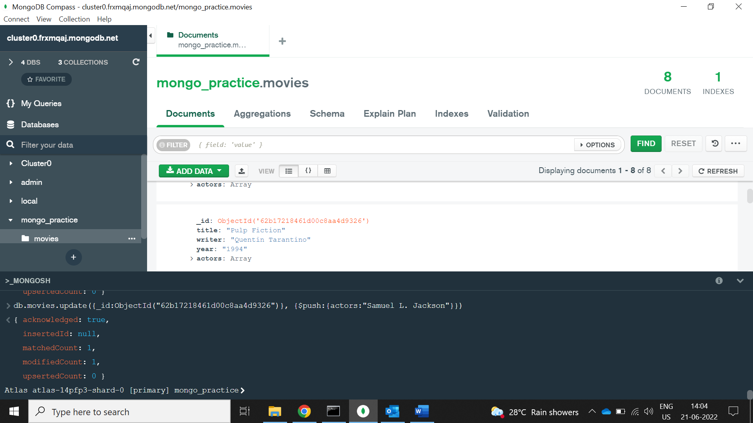

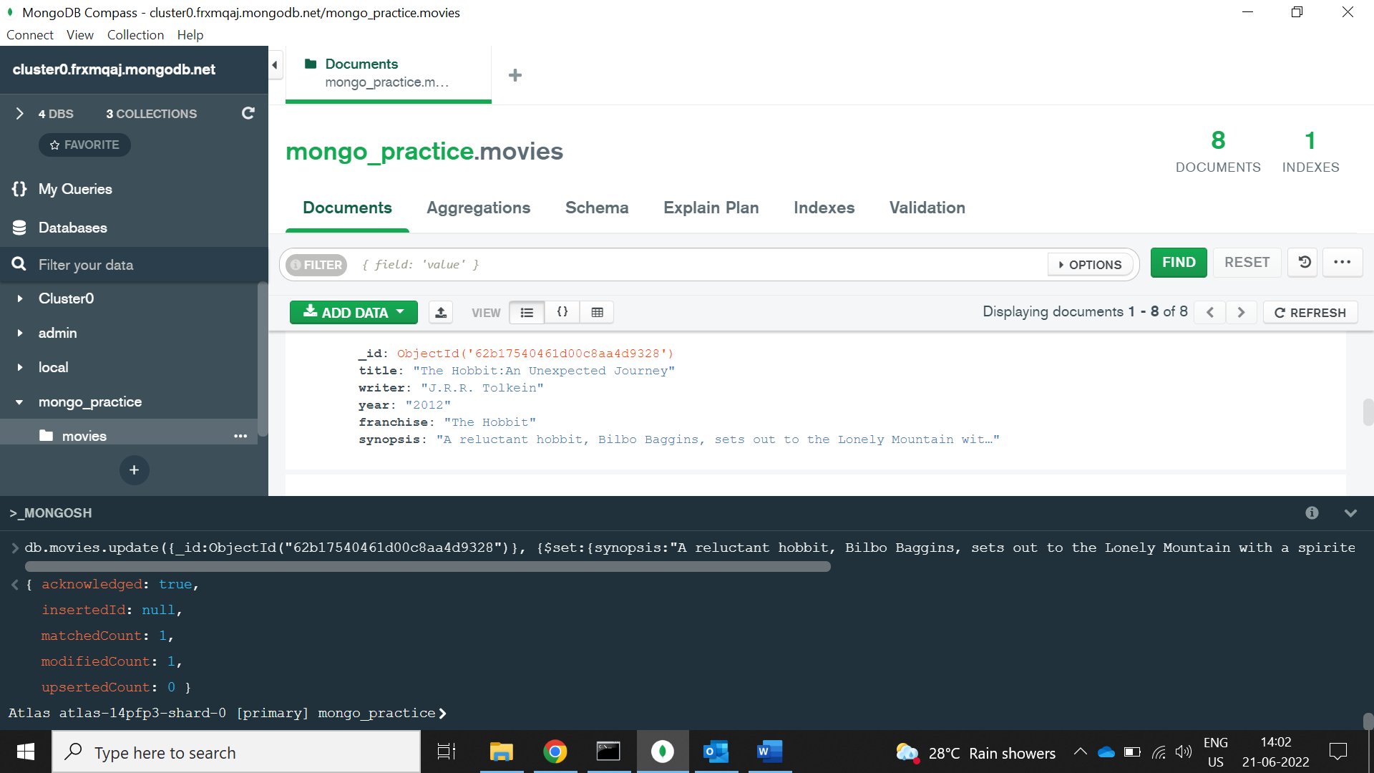



## Text Search

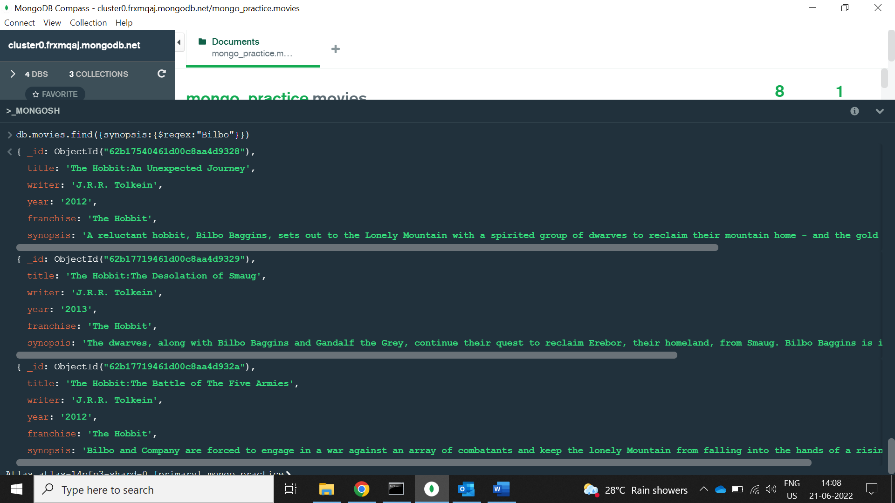

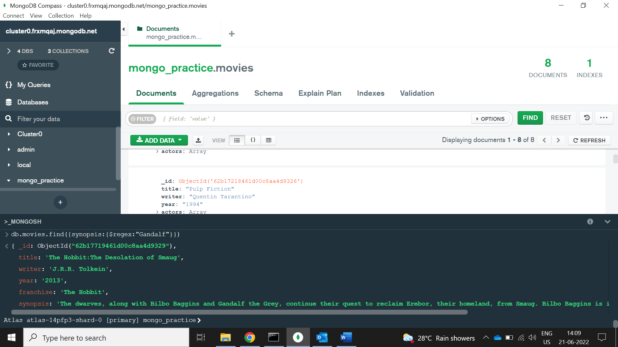

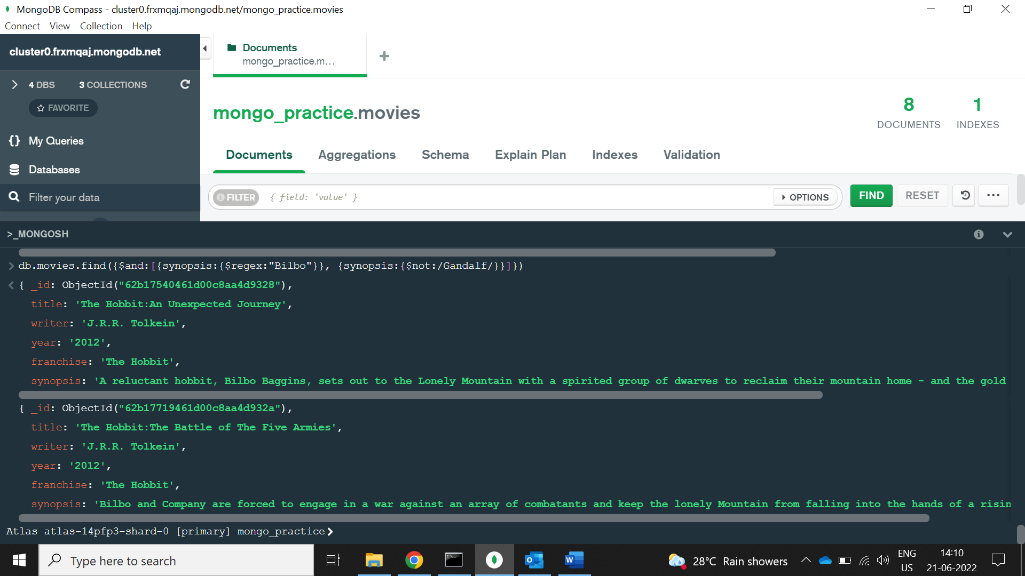

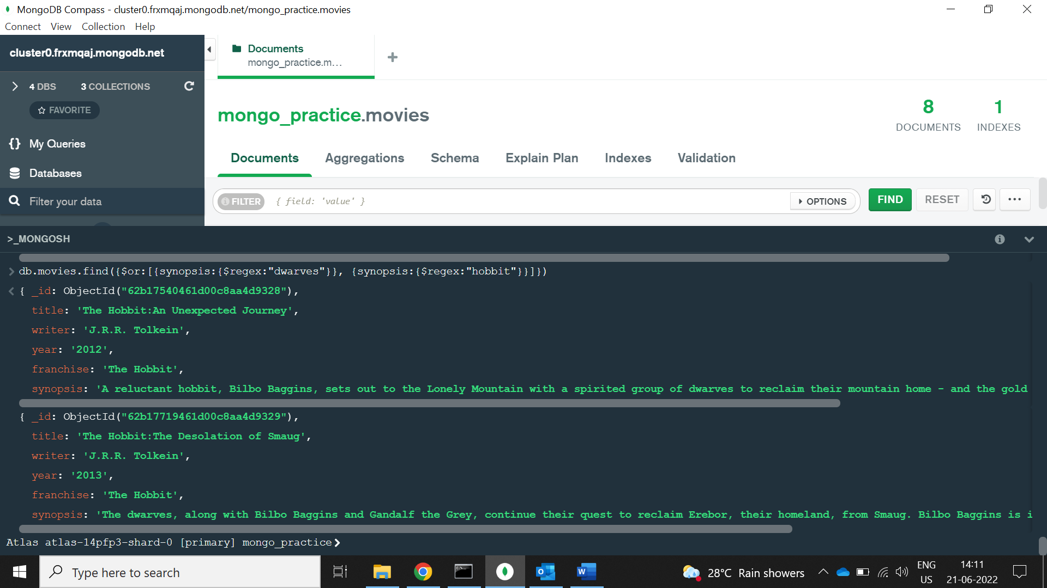

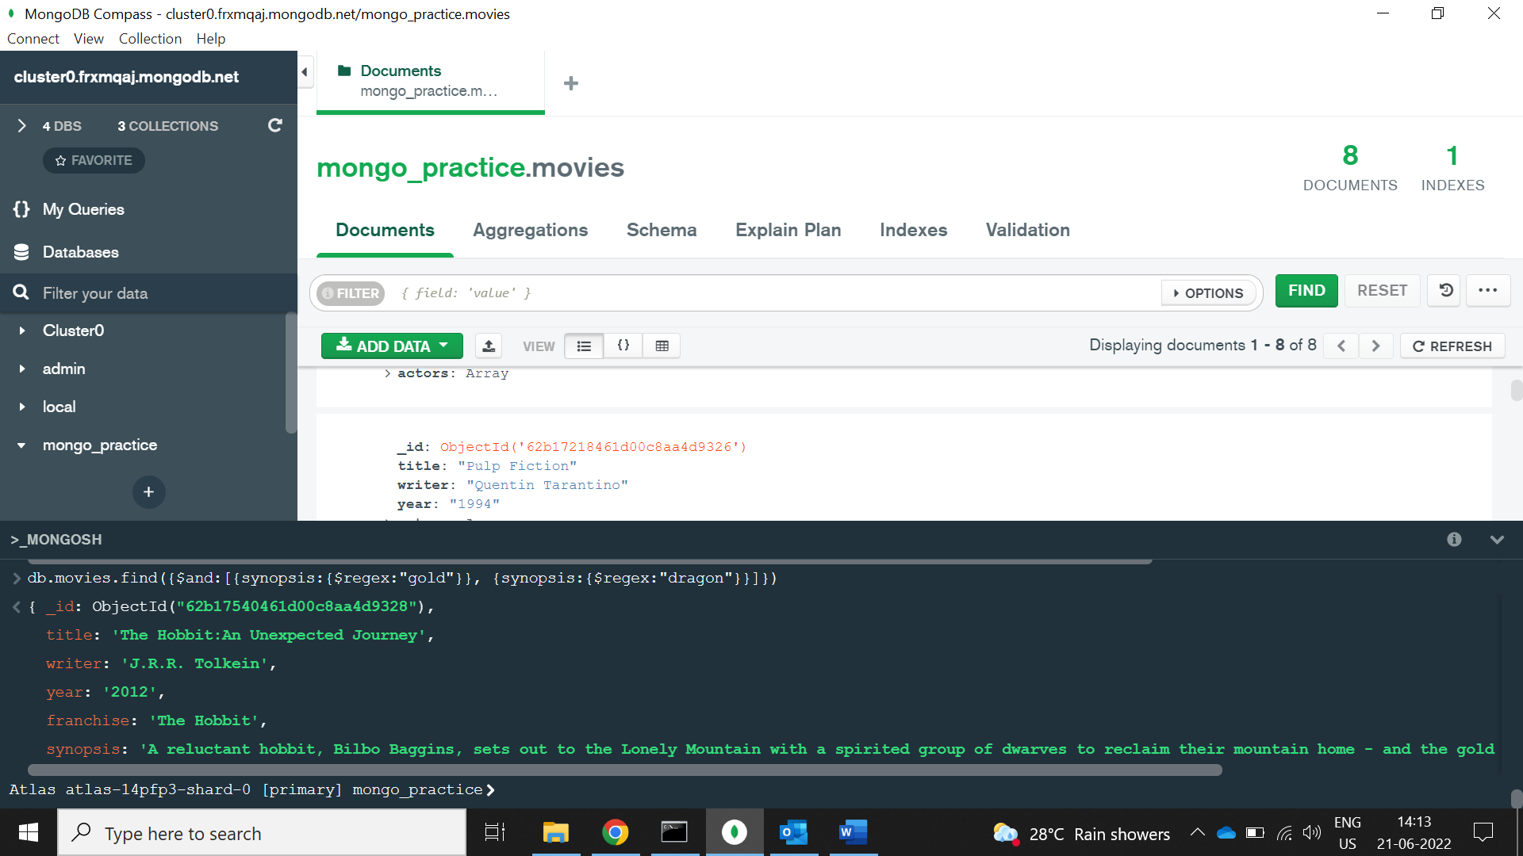

## Delete Documents

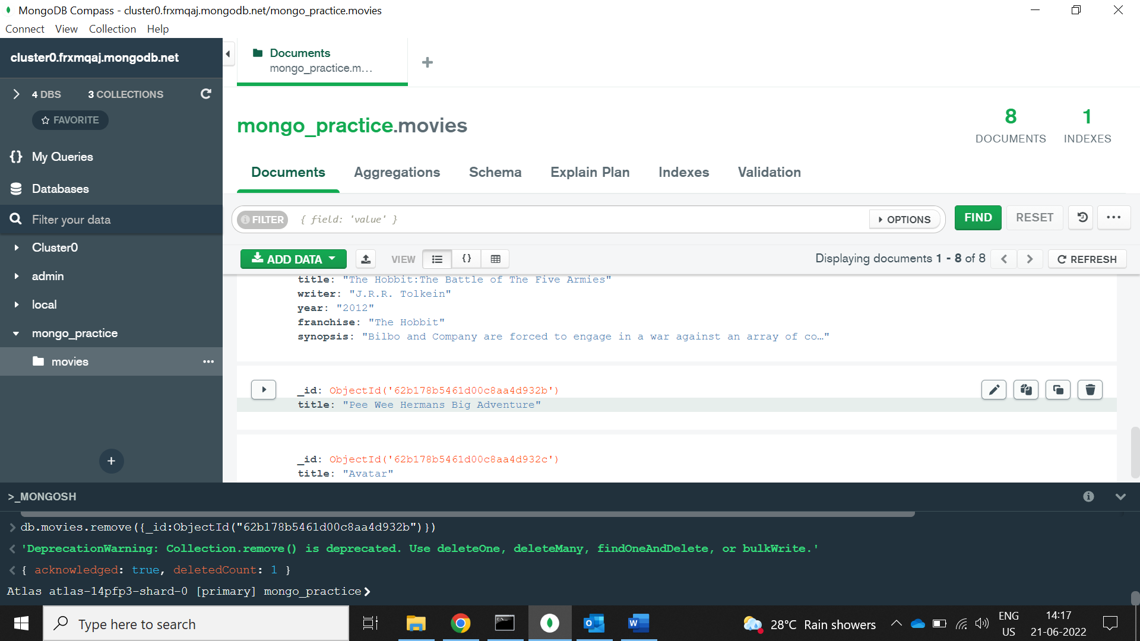

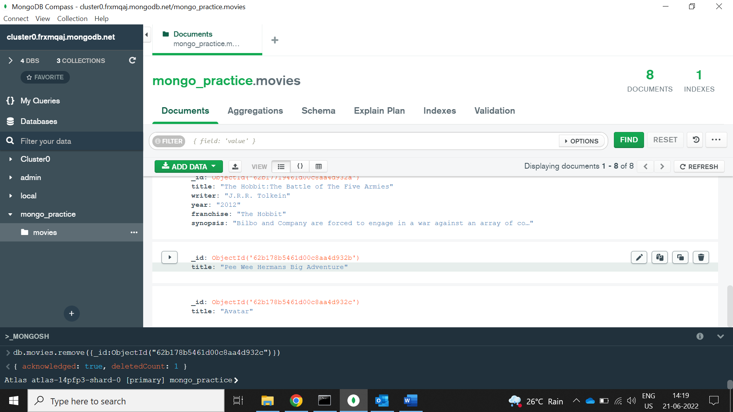

1. find all users

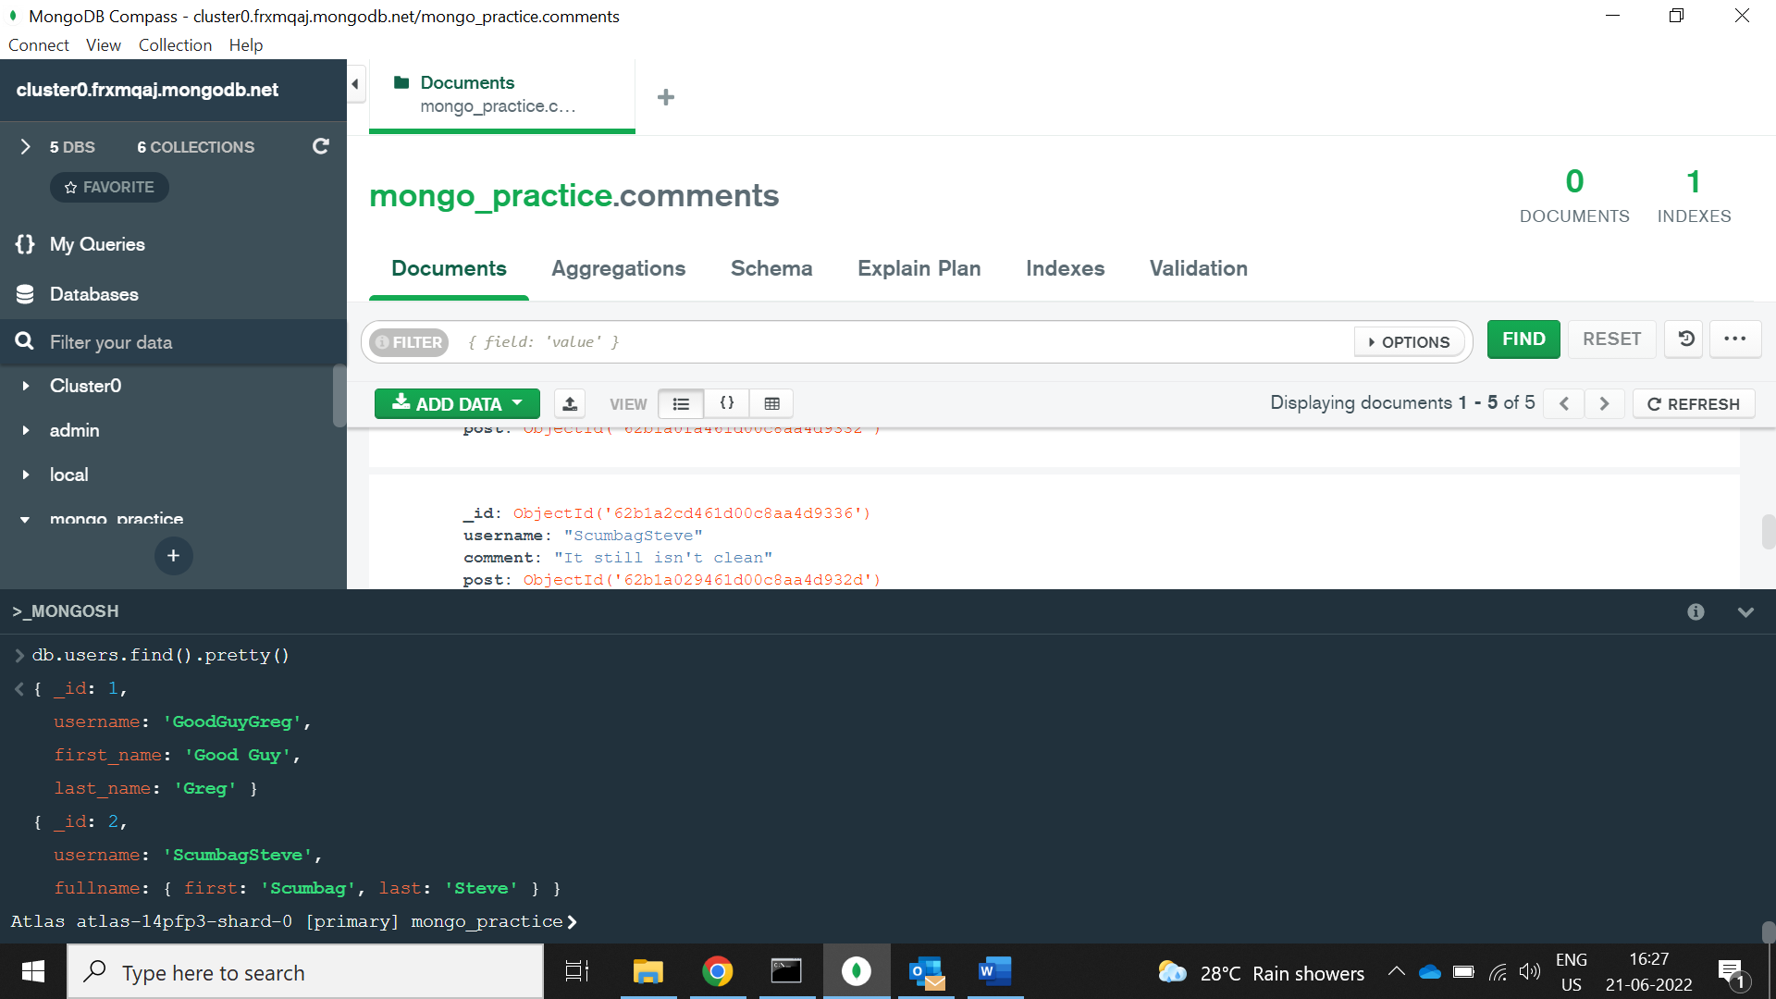

1. find all posts

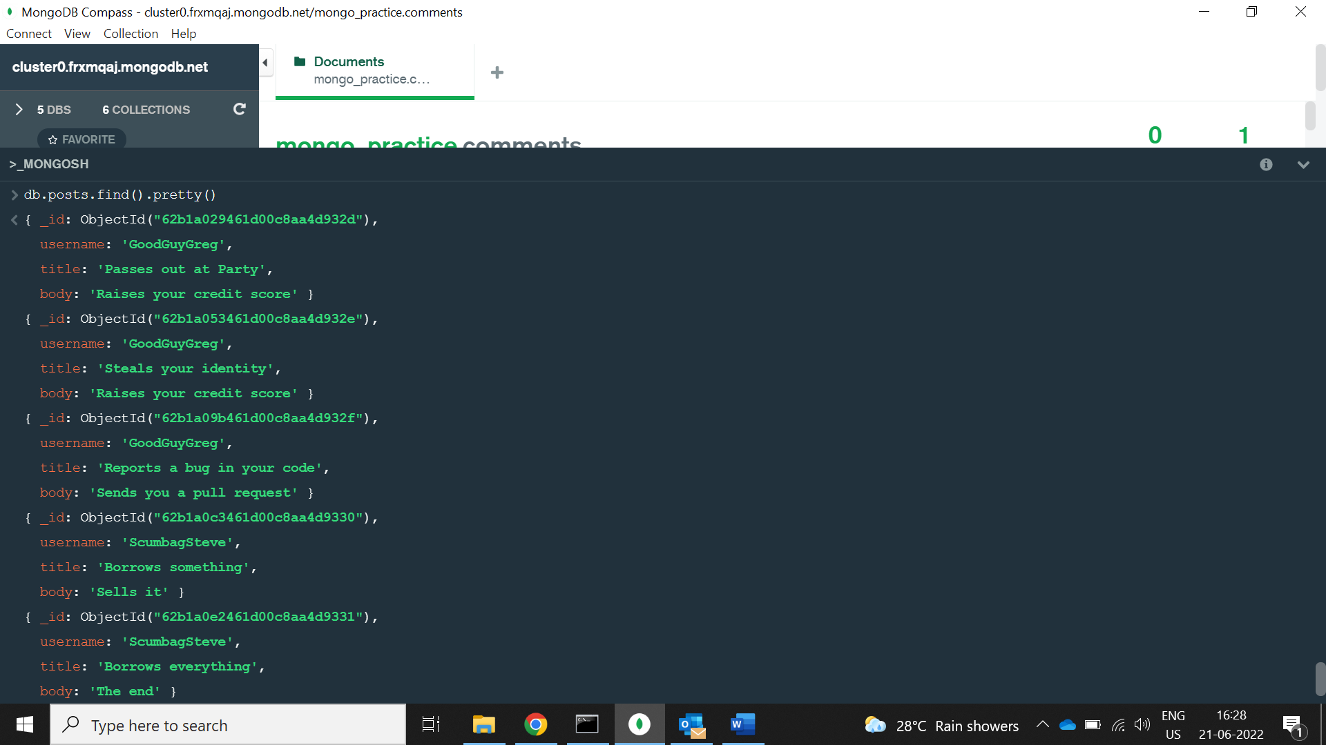

1. find all posts that was authored by "GoodGuyGreg"

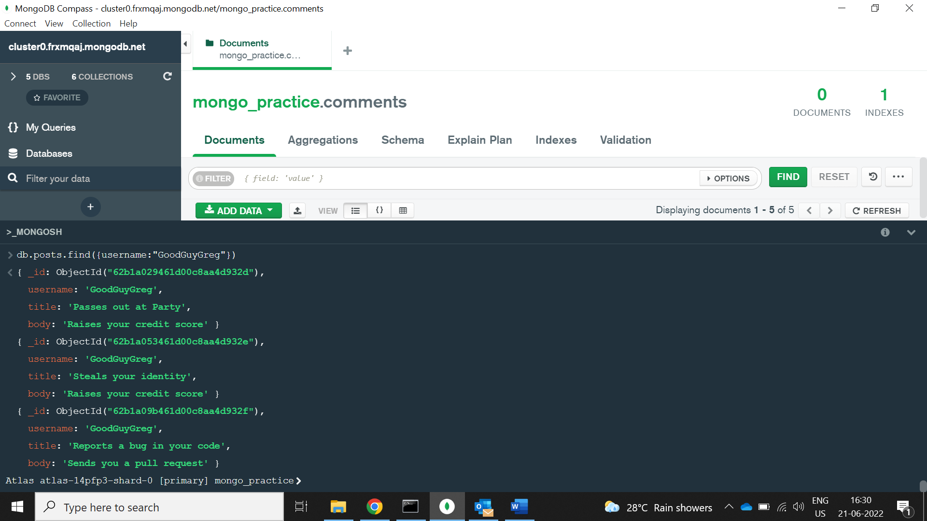

1. find all posts that was authored by "ScumbagSteve"

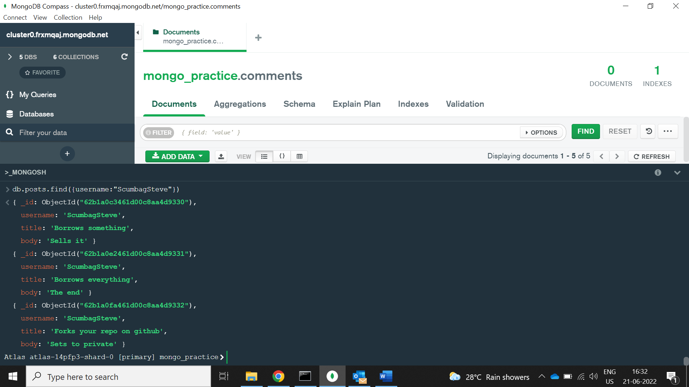

1. find all comments

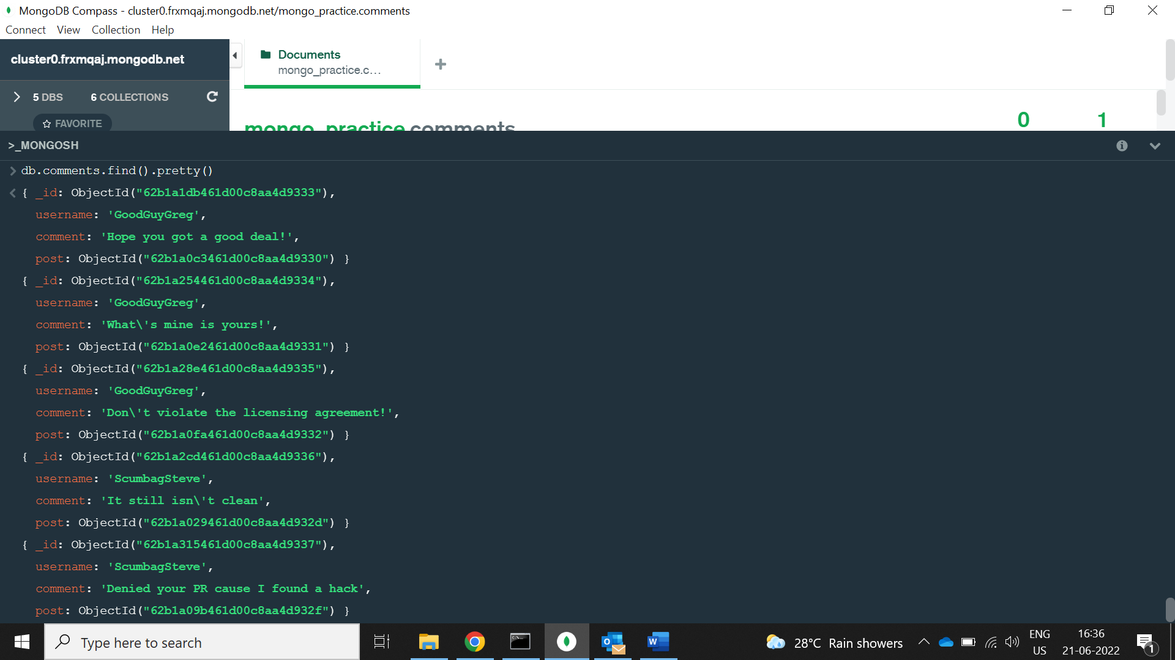

1. find all comments that was authored by "GoodGuyGreg"

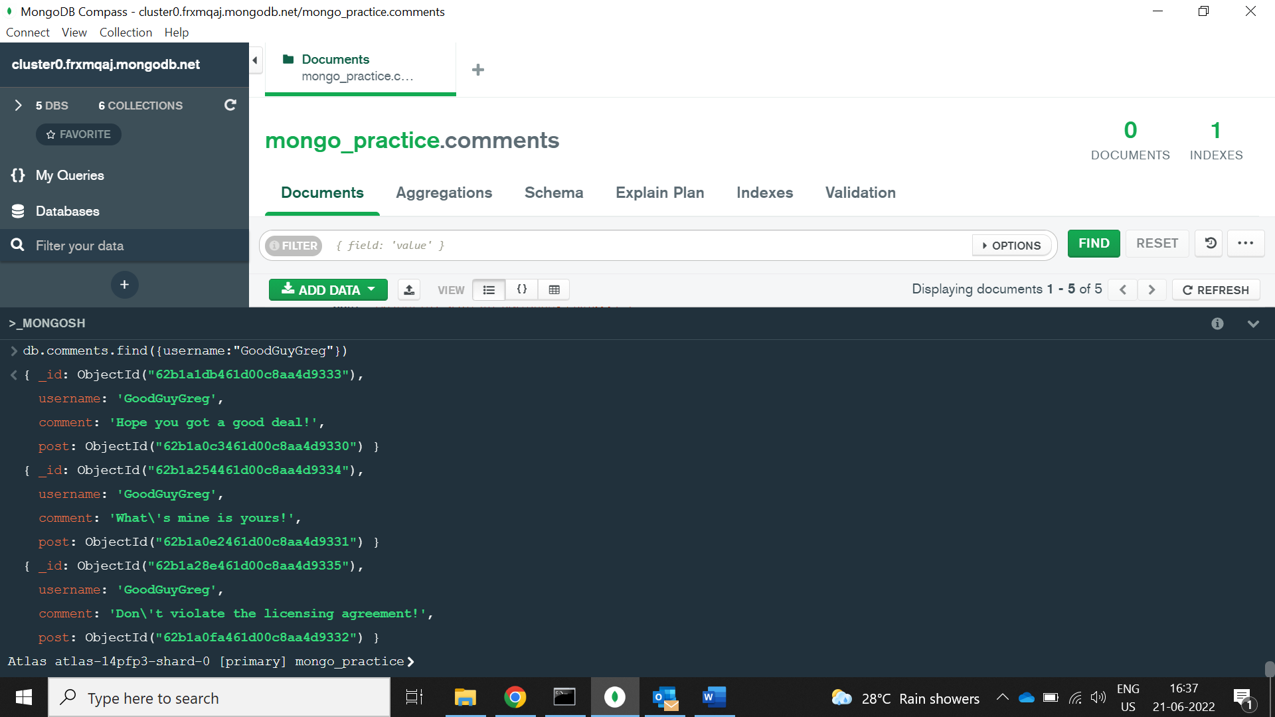

1. find all comments that was authored by "ScumbagSteve"

